Personal Insurance, Inc.

Shelly Cashman Access 2019 | Module 5: SAM Project 1a



Multiple-Table Forms

# ~~GETTING STARTED~~

* ~~Open the file~~ **~~SC_AC19_5a_~~*~~FirstLastName~~*~~_1.accdb~~**~~, available for download from the SAM website.~~
* ~~Save the file as~~ **~~SC_AC19_5a_~~*~~FirstLastName~~*~~_2.accdb~~** ~~by changing the “1” to a “2”.~~

~~If you do not see the .accdb file extension in the Save As dialog box, do not type it. The program will add the file extension for you automatically.~~

* ~~Open the~~ **~~_GradingInfoTable~~** ~~table and ensure that your first and last name is displayed as the first record in the table. If the table does not contain your name, delete the file and download a new copy from the SAM website.~~
* ~~PROJECT STEPS~~

1. ~~Personal Insurance, Inc. is a national company that insures homeowners and renters. As a regional manager, you need to be able to modify tables and create multiple-table forms.  
      
   Open the~~ *~~Customers~~* ~~table in Design View. Use the Input Mask Wizard to create an input mask for the~~ *~~PhoneNumber~~* ~~field. Store the data without symbols in the mask. Save the change to the~~ *~~Customers~~* ~~table without closing it.~~
2. ~~Switch the~~ *~~Customers~~* ~~table to Datasheet View, and then add a new field named~~ **~~CustomerNotes~~** ~~at the end of the table. Use~~ **~~Long Text~~** ~~as the data type for the field. Save the change to the table.~~
3. ~~With the~~ *~~Customers~~* ~~table still open in Datasheet View, update the record for customer Xavier Wilcox (who has the CustomerID 11010) by completing the following tasks:~~
   1. ~~Using the input mask, enter~~ **~~717-555-3443~~** ~~in the~~ *~~PhoneNumber~~* ~~field.~~
   2. ~~Enter the text~~ **~~Has two rental properties~~** ~~in the~~ *~~CustomerNotes~~* ~~field.   
        
      Close the table.~~
4. ~~Open the~~ *~~Claims~~* ~~table in Design View, and then add a new field with the name~~ **~~ClaimEstimate~~** ~~following the~~ *~~ClaimAmount~~* ~~field. Use~~ **~~Attachment~~** ~~as the data type for the field, and use~~ **~~Damage Estimate~~** ~~as the caption property for the field. Save the change to the table, and then close the table.~~
5. ~~Modify the~~ *~~Customer Data Entry Form~~* ~~by completing these tasks:~~
   1. ~~Open the~~ *~~Customer Data Entry Form~~* ~~in Design View.~~
   2. ~~Open the field list for the form.~~
   3. ~~Add the~~ **~~PhoneNumber~~** ~~field to the form directly above the~~ *~~Region~~* ~~label and text box. The left edge of the~~ *~~PhoneNumber~~* ~~text box is at the 5" mark on the horizontal ruler and the top of the label and control are approximately at the 1.3" mark on the vertical ruler.  
        
      Save the changes to the form, confirm that it matches Figure 1, and close the~~ *~~Customer Data Entry Form~~*~~.~~

* ~~Figure 1: Customer Data Entry Form—Design View~~

~~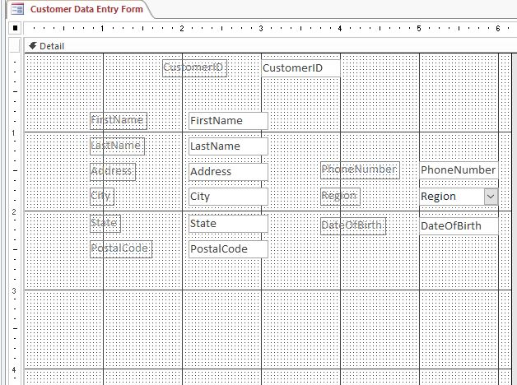~~

1. ~~Select the~~ *~~Umbrella~~* ~~table, and create a new form in Design View. Update the form by completing these tasks:~~
   1. ~~Add the~~ *~~PolicyNumber~~*~~,~~ *~~CustomerID~~*~~,~~ *~~Premium~~*~~, and~~ *~~Coverage~~* ~~fields to the Detail section of the form. The left edges of the controls are at the 3" mark on the horizontal ruler. The controls are separated vertically by approximately 0.2". If necessary, reposition the controls and their labels after adding them to the form.~~
   2. ~~Save the form with the name~~ **~~Umbrella Data Entry Form~~** ~~but do not close the form.~~
   3. ~~Add a title to the form. The title of the form should match the name of the form.  
        
      Save the form, confirm that it matches Figure 2, and close the~~ *~~Umbrella Data Entry Form~~*~~.~~

* ~~Figure 2: Umbrella Data Entry Form—Design View~~

~~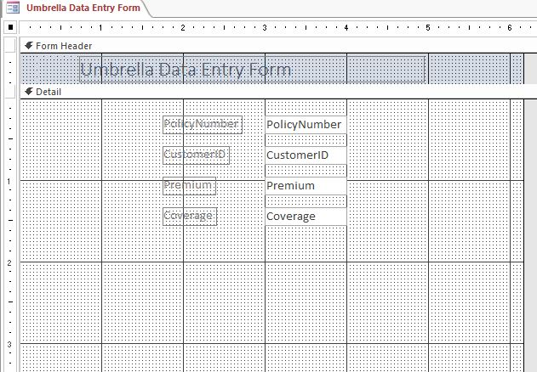~~

1. ~~Open the~~ *~~Customer Master Form~~* ~~in Design View, and ensure that the Use Control Wizards button is selected. Then, use the Subform/Subreport Wizard to add a subform with the following options:~~
   1. ~~Use the~~ *~~Homeowners~~* ~~table for the subform.~~
   2. ~~Select the~~ *~~PolicyNumber~~* ~~and~~ *~~Premium~~* ~~fields from the~~ *~~Homeowners~~* ~~table to add to the form.~~
   3. ~~Accept the default link (~~**~~Show Homeowners for each record in <SQL Statement> using CustomerID~~**~~) to link the main form to the subform.~~
   4. ~~Save the subform as~~ **~~Homeowners subform~~** ~~(which is the default name).~~
   5. ~~If necessary, reposition the subform so that the top-left edge of the subform control is at the 2.5" mark on the vertical ruler and the .5" mark on the horizontal ruler. The bottom-right edge of the subform control is at 3.5" mark on the vertical ruler and the 5.5" mark on the horizontal ruler.  
        
      Save and close the form.~~

* ~~Figure 3: Customer Master Form—Design View~~

~~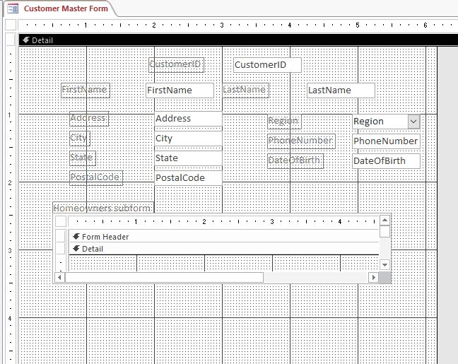~~

1. ~~Open the~~ *~~Customer-Renters Master Form~~* ~~in Design View, and then modify it by resizing the width of the subform so that the right edge is at approximately 7.5" on the horizontal ruler. Confirm that the form matches Figure 4, and then save but do not close it.~~
2. ~~With the~~ *~~Customer-Renters Master Form~~* ~~still open in Design View, modify the form title by completing the following tasks:~~
   1. ~~Change the font color of the title to~~ **~~Dark Red~~** ~~(1st column, 7th row of the Standard Colors palette).~~
   2. ~~Change the font size of the title text to~~ **~~22 point~~**~~.~~
   3. ~~Apply the~~ **~~Etched~~** ~~special effect to the title.  
        
      Save the form, confirm that it matches Figure 4, and close the~~ *~~Customer-Renters Master Form~~*~~.~~

* ~~Figure 4: Customer-Renters Master Form—Design View~~

~~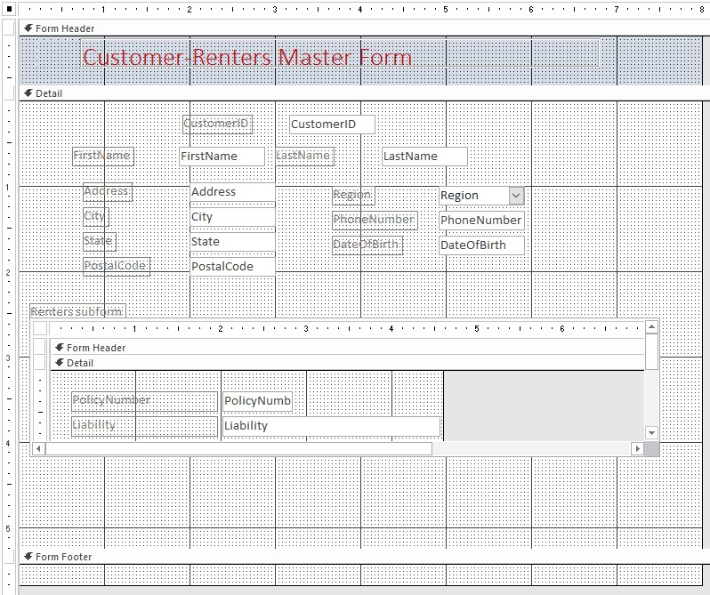~~

1. ~~Open the~~ *~~Claims Financial Form~~* ~~in Design View, and then modify the form by completing~~ ~~the following tasks:~~
   1. ~~Delete the~~ *~~ClaimRepNumber~~* ~~control and the accompanying label.~~
   2. ~~Change the label for the~~ *~~ClaimAmount~~* ~~control using~~ **~~Approved~~** ~~as the new label name.  
        
      Save and close the form.~~
2. ~~Open the~~ *~~Umbrella Customer Form~~* ~~in Design View, and then modify the form to match Figure 5 by completing the following tasks:~~
   1. ~~Select the~~ *~~FirstName~~*~~,~~ *~~LastName~~*~~,~~ *~~State~~*~~,~~ *~~Premium~~*~~, and~~ *~~Coverage~~* ~~controls and labels simultaneously.~~
   2. ~~Adjust the spacing of these fields to have equal vertical spacing.  
        
      Save, but do not close the form.~~
3. ~~With the~~ *~~Umbrella Customer Form~~* ~~still open in Design View, change the tab order so that users tab to the~~ *~~LastName~~* ~~field immediately after the~~ *~~FirstName~~* ~~field. Save and close the form.~~

* ~~Figure 5: Umbrella Customer Form—Design View~~

~~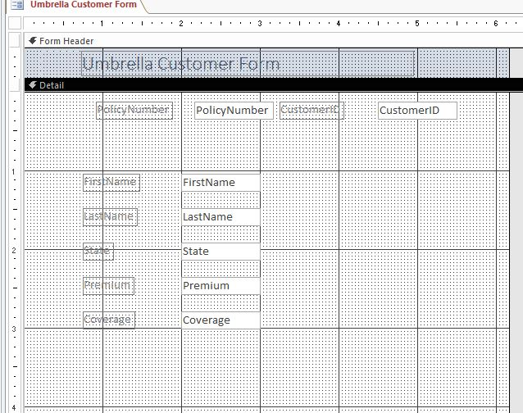~~

1. ~~Open the~~ *~~Basic Homeowners Form~~* ~~in Design View, and then change the background color of the form to~~ **~~Light Gray 2~~** ~~(1st column, 3rd row of the Standard Colors palette). Save the form, but do not close it.~~
2. ~~With the~~ *~~Basic Homeowners Form~~* ~~still open in Design View, modify the form by performing the following tasks:~~
   1. ~~Select the~~ *~~PolicyNumber~~* ~~label,~~ *~~PolicyNumber~~* ~~control,~~ *~~CustomerID~~* ~~label, and~~ *~~CustomerID~~* ~~control simultaneously. Align the controls to the top.~~
   2. ~~Select the~~ *~~Liability~~* ~~control, the~~ *~~PropertyDamage~~* ~~control, the~~ *~~Premium~~* ~~control, and the~~ *~~Deductible~~* ~~control simultaneously. Do not select any labels, and make sure the~~ *~~TotalCoverage~~* ~~control is not selected. Align the controls to the left.  
        
      Save, but do not close the form.~~
3. ~~With the~~ *~~Basic Homeowners Form~~* ~~still open in Design View, add a title to the form using~~ **~~Basic Homeowners Form~~** ~~as the name. (~~*~~Hint~~*~~: This is the default name.) Save, but do not close the form.~~
4. ~~With the~~ *~~Basic Homeowners Form~~* ~~still open in Design View, change the Tab Stop property to~~ **~~No~~** ~~for the~~ *~~TotalCoverage~~* ~~field. Save the form, confirm that it matches Figure 6, and close the~~ *~~Basic Homeowners Form~~*~~.~~

* ~~Figure 6: Basic Homeowners Form—Design View~~

~~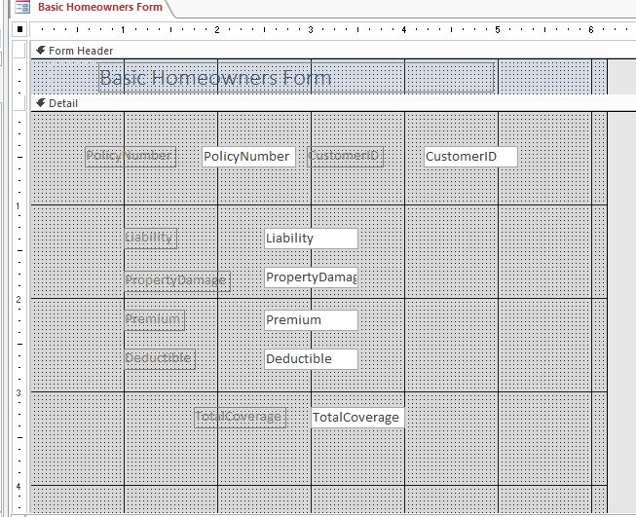~~

1. ~~Open the~~ *~~ClaimsRep Skills~~* ~~Query in Design View, and then modify the query to find all~~ ~~claims reps hired before~~ **~~1/1/2016~~** ~~who have~~ **~~construction~~** ~~skills.~~ *~~(Hint:~~* ~~The~~ *~~SpecialNotes~~* ~~field has the Long Text data type.) The query should return one record. Run the query, and then save and close it.~~

~~Save and close any open objects in your database. Compact and repair your database, close it, and then exit Access. Follow the directions on the SAM website to submit your completed project.~~